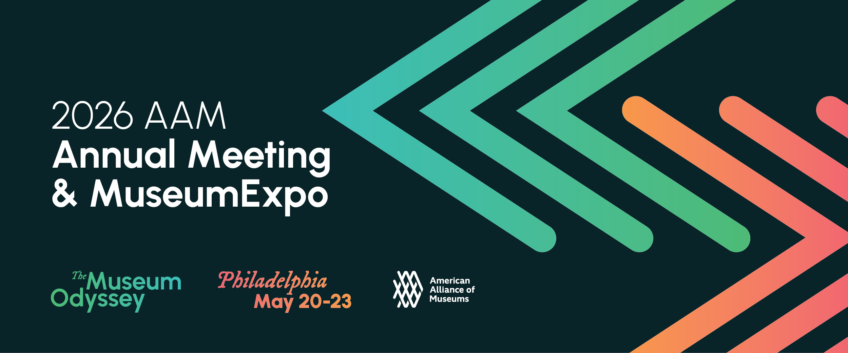

Simply copy and complete the template below
Date

Dear (supervisor’s name),

I am requesting approval to attend the 2026 American Alliance of Museums Annual Meeting & MuseumExpo (AAM 2026), taking place May 20-23 in Philadelphia, PA. The AAM Annual Meeting is known as the largest museum conference in the world and one of the most enriching professional development experiences a museum professional can have. Through access to emerging strategies, peer networks, and solutions directly applicable to [YOUR CURRENT PROJECTS/CHALLENGES], I expect to bring back immediate learnings to implement.

Why AAM 2026?
AAM 2026 is the museum field's premier professional development event, bringing together 4,000+ museum professionals from around the world to collaborate across disciplines. Unlike other conferences, AAM offers:

- Nearly 200 educational sessions covering critical topics from [insert topic of interest] to [insert second topic of interest]
- Hands-on workshops with immediately actionable takeaways
- Direct access to industry leaders and innovative peers solving similar challenges
- The MuseumExpo featuring 350+ vendors showcasing cost-saving solutions and technologies
- Targeted networking with professionals in [YOUR SPECIFIC ROLE/DEPARTMENT]

This year's theme, The Museum Odyssey, explores the evolving roles museums play in society—particularly relevant as America marks its 250th anniversary and museums navigate unprecedented change.

Direct Benefits to [YOUR ORGANIZATION]

Attending AAM 2026 will enable me to:

Immediate Application:
- Bring back proven strategies for [SPECIFIC PROJECT/INITIATIVE YOU'RE WORKING ON]
- Learn cost-saving approaches to [SPECIFIC CHALLENGE YOUR MUSEUM FACES]
- Identify potential partnerships and funding opportunities
- Discover technologies and vendors that can improve [SPECIFIC OPERATION]

Knowledge Transfer:
- Share insights with [NUMBER] colleagues through post-conference presentation
- Implement best practices in [YOUR DEPARTMENT/AREA]
- Apply new frameworks to [CURRENT STRATEGIC PRIORITY]

Network Development:
- Build relationships with peers with similar roles and responsibilities
- Connect with experts in [YOUR SPECIALTY AREA]
- Join [RELEVANT COMMUNITIES OF PRACTICE]
  - NOTE: in 2026, AAM is piloting several communities of practice. Please check the website for updates on these groups in early 2026.

Relevant Programming for My Role

AAM 2026 offers comprehensive programming across key functional areas. I will focus on sessions most relevant to my responsibilities and [YOUR ORGANIZATION]'s priorities:

[Select and customize the most relevant area(s) from the AAM 2026 session tracks:]

- Collections Stewardship & Conservation
Evolving approaches to preserving physical and digital collections that reflect ethical stewardship, public values, and inclusive, sustainable access.
- Storytelling & Engagement
Using narrative, interpretation, and engagement to build lasting inter- and intragenerational connections that foster creative aging, lifelong learning, social cohesion, and cultural continuity.
- Mission, Leadership & Institutional Evolution
Aligning mission and leadership with enduring values while evolving institutional identity for resilience across time.
- Infrastructure, Security & Continuity Planning
Designing facilities, systems, and risk management strategies that ensure institutional longevity and adaptive capacity.
- Evaluation for Legacy & Generational Impact
Using research, evaluation, and longitudinal data to understand, demonstrate and sustain institutional relevance across generations.
- Sustaining Institutional Capacity & Fundraising
Developing inclusive, forward-looking financial and operational models to secure museums’ long-term stability and public trust.
- Scholarship & Theories of Time
Drawing on historical, cultural, and museological scholarship to shape long-term perspectives and guide institutional practices.
- Immersive and Multisensory Experience Design
Designing impactful visitor experiences using theatrical techniques, immersive technologies, and sensory storytelling.
- Interpretation and the Meaning of Time
Exploring how museums help audiences experience and understand time through interpretive strategies that connect different moments and perspectives.
- Digital Storytelling and Technology
Using digital platforms and tools to create inclusive, engaging narratives that resonate across time and identities.
- Ethics of Reconstruction and Representation
Navigating ethical challenges in how museums reimagine, represent, or recreate knowledge, environments, and cultural expressions over time.
- Co-Created and Community-Centered Narratives
Collaborating with communities to co-create narratives that reflect diverse experiences and evolving understandings of the past, present, and future.
- Contemporary Collecting & Documentation
Developing responsive strategies to collect and preserve materials that reflect the present moment.
- Interpretation of Social, Cultural, Scientific, and Environmental Issues
Creating exhibitions and programs that address the complex social, cultural, scientific, or environmental issues with research, insight, and inclusion.
- Media, Publications & Public Narrative
Using communications, editorial platforms, and storytelling to shape public understanding of unfolding events in real time.
- Fundraising & Values Alignment
Aligning fundraising strategies and donor relationships with evolving public values and institutional purpose.
- Participatory Archives & Shared Authority
Partnering with communities to co-create archives, oral histories, and narratives rooted in shared experience.
- Scholarship & Real-Time Research
Applying scholarly and community-based research to interpret the present within broader historical context.
- Strategic Foresight & Futures Planning
Using tools like scenario planning and horizon scanning to anticipate change and shape future realities.
- Civic & Community Engagement
Building inclusive platforms for dialogue, participation, and advocacy that help communities navigate change together.
- Institutional Resilience & Workforce Strategy
Evolving leadership, staffing, and business models to strengthen museums for long-term adaptability.
- Innovation & Cross-Sector Collaboration
Pursuing new ideas, technologies, and partnerships to drive cultural and organizational innovation.
- Responding to Forces of Change
Addressing external drivers—such as climate, technology, and social transformation—with agility and vision.
- Leadership, Governance & Strategy
Advancing ethical leadership, effective governance, and strategic planning aligned with mission and values.
- Human Resources & Organizational Culture
Supporting workforce development, inclusive hiring practices, and positive, adaptive organizational culture.
- Collections & Registration
Promoting best practices in collections care, documentation, access, and management.
- Curation & Exhibition Development
Innovating curatorial methods and exhibition design for diverse, engaging experiences.
- Education, Engagement & Visitor Experience
Enhancing interpretation, learning models, and visitor services and experiences that reflect community needs and interests.
- Marketing, Communications & Community Relations
Building trust and visibility through storytelling, media, and strategic community engagement.
- Fundraising, Membership & Revenue Strategy
Developing sustainable income strategies and meaningful donor and member relationships.
- Finance, Operations & Risk Management
Ensuring financial health, operational excellence, and preparedness for risk and disruption.
- Technology & Digital Practice
Integrating digital tools and infrastructure across museum functions for greater impact and reach.
- Evaluation, Research & Field Innovation
Applying data, evaluation, and research to drive innovation and continuous improvement.

Total Conference Investment:
The numbers included below are estimates. Please research and update the cost for each row based on your specific requirements.

Expense Category | Cost | Budget-friendly considerations
Conference Registration | $595-$995 | Early bird and member discounts can save up to $400 off the on-site rate
Roundtrip transportation | $600 | Book 60+ days ahead for savings on travel
Hotel | $800-900 | Book in the AAM hotel block for discounted rates
Meals and Incidentals | $200 | All evening parties and the MuseumExpo Opening Reception include food.
Total investment

Value Comparison:
If you/your employer are weighing alternative types of professional development, below is a cost comparison to common alternative types of professional development. These are estimates; you can customize this section to match the alternatives under consideration.

Professional Development Option | Typical Cost | What You Get
AAM 2026 Conference | $700 - 2,500 (edit based on your travel expenses) | 200 sessions, workshops, networking, MuseumExpo access, 4 days
Single university course | $1,500-6,000 | One topic, semester-long
Private consultant workshop | $2,000-5,000 | One topic, 1-2 days
Online certificate program | $500-3,500 | Self-paced, limited networking
Individual coaching sessions (6 sessions) | $1,200-3,000 | One-on-one but narrow focus

