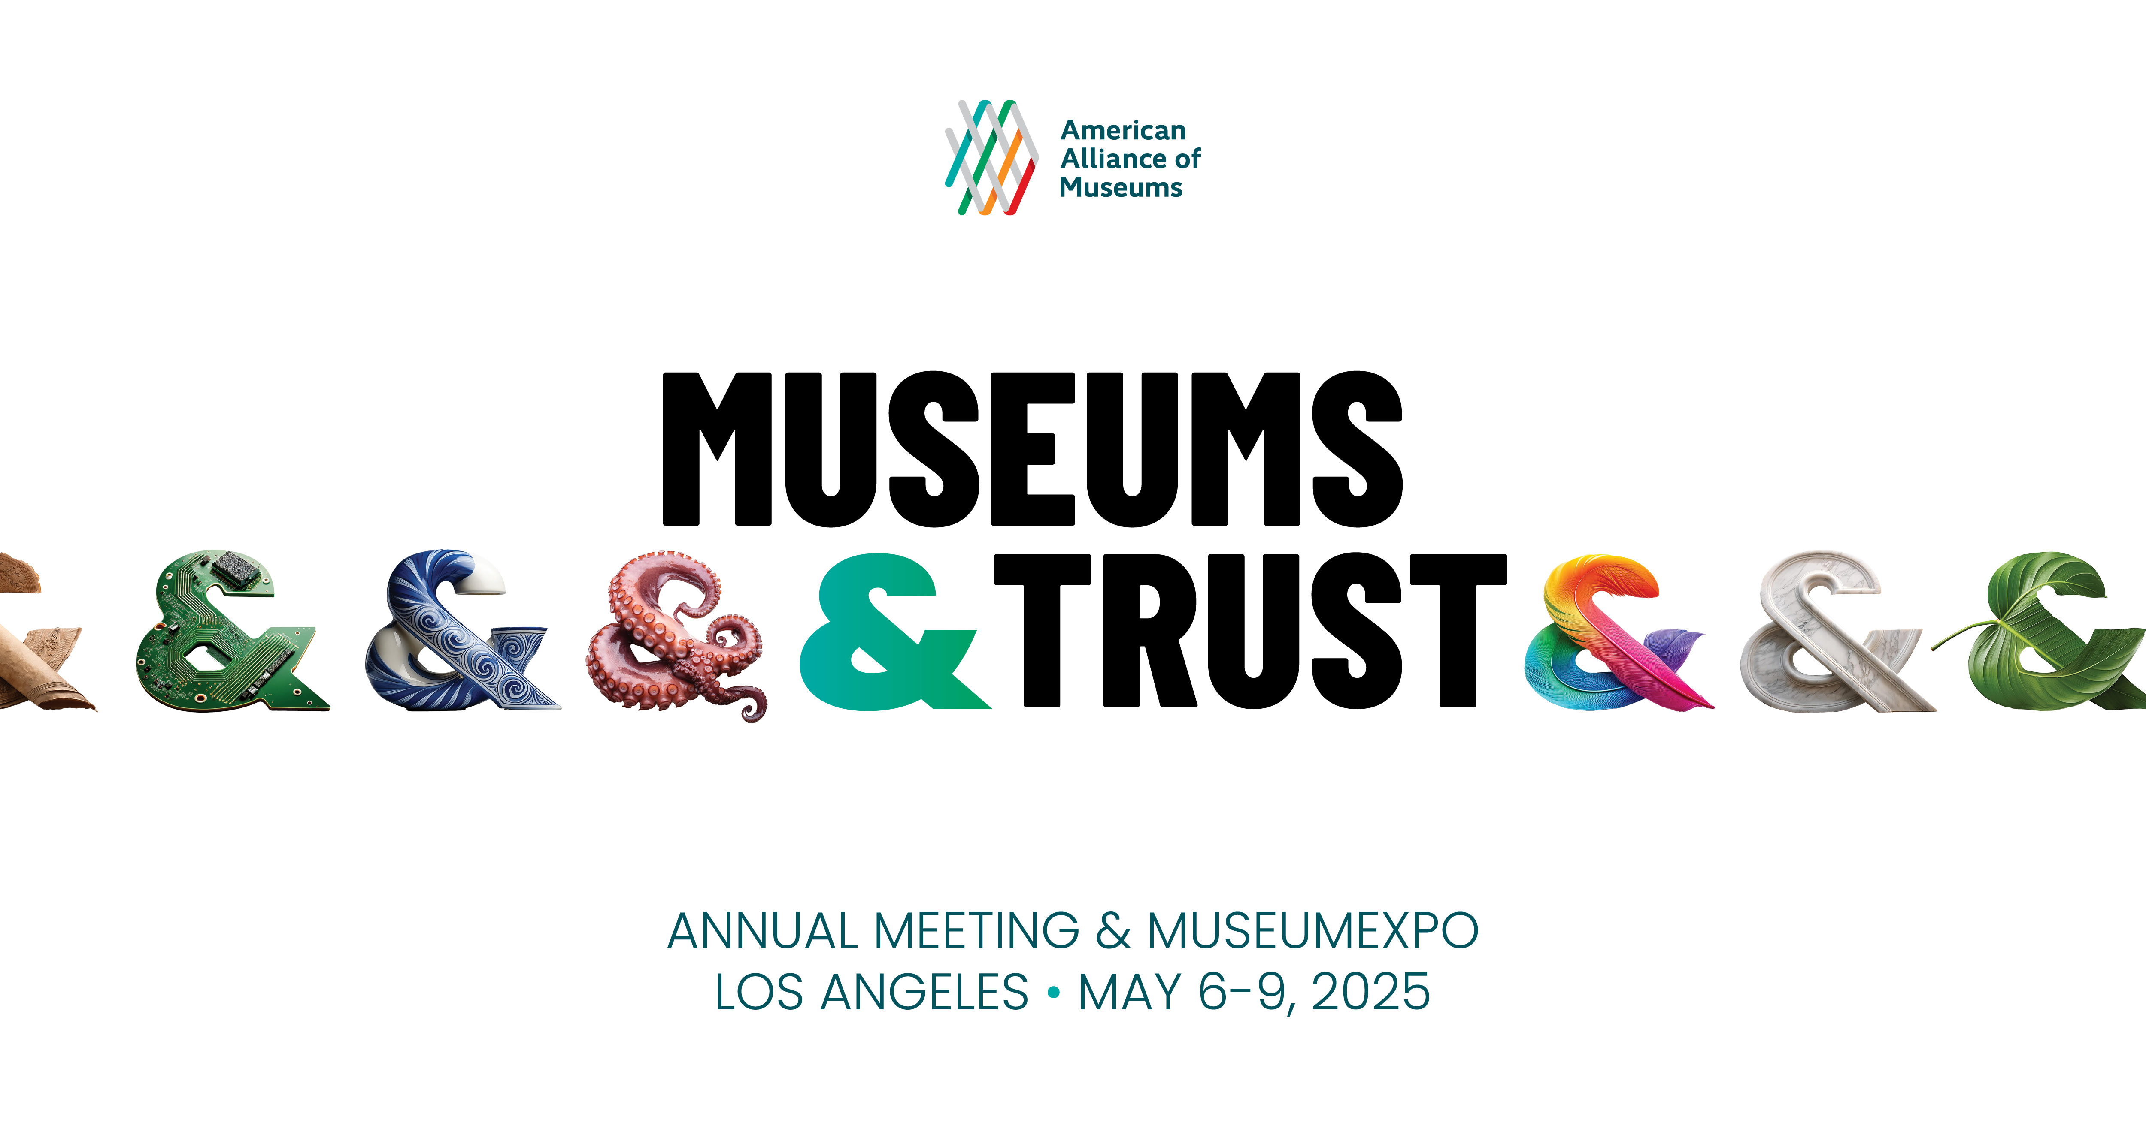

**Simply copy and complete the template below**

Date

Dear (supervisor’s name),

I am requesting your support for my attendance to the 2025 American Alliance of Museums Annual Meeting & MuseumExpo (AAM 2025), May 6-9 in Los Angeles, CA. The conference will enable me to participate in (tracks/sessions/events/discussions)that are directly applicable to my position and will also allow me to network with others in the field to get new ideas and help strengthen our institution.

**Why AAM 2025?**

AAM 2025 is unlike other conferences and professional development opportunities because it brings together the entire museum ecosystem to collaborate across disciplines to learn from each other on issues like social impact, financial wellness, and organizational culture. There are sessions and meetups for (your specific profession) that can help me connect with, and borrow ideas and strategies from, others who have successfully (insert an initiative or project you’re working on).

**How will this benefit (your organization)?**

The leaders of relevant and resilient museums have long turned to the AAM Annual Meeting to gain deeper insights into emerging trends. At the AAM Annual Meeting, we will learn from and network with our peers who are addressing emerging issues, as well as the partners that can help us address the unique challenges and opportunities our museum and community faces.

At AAM 2025, I will be participating in hands-on sessions related to the following topics:

*(Here you may want to list content that most apply to your responsibilities. Below is list of the AAM 2025 focus areas and the topics covered in each.)*

**Purpose**:  strategic planning; community partnerships; diversity, equity, accessibility, and inclusion (DEAI); board governance; leadership development; implementation of mission-driven initiatives; organizational resilience; and change management.

**Practice**: education, exhibitions, curation, and collections stewardship to seek truth, validate information, and uphold integrity. Potential topics include research methodologies, object-based learning techniques, bias mitigation, cultural sensitivity, visitor evaluation, environmental stewardship, application of emerging technologies such as virtual reality and augmented reality, and consensus-building.

**Process**: guidelines, protocols, processes, or ethical frameworks governing museum operations that engender trust, in areas such as collection management; facilities management; conservation; financial management; curation and research; education; interpretation; ethics; representation; and diversity, equity, accessibility, and inclusion. Potential topics can include sustainable practices, technology integration (e.g., virtual reality and augmented reality), visitor data use, digital or physical preservation, cybersecurity, accessibility standards, facility design, collections management, human resources, and evidence-based research.

**Programs**: initiatives, outreach efforts, and programs developed by museums to engage diverse audiences and communities; foster dialogue, understanding, and collaboration; leverage technology; forge interdisciplinary or cross-disciplinary approaches; and strengthen community partnerships. Potential topics include staff and volunteer development, intergenerational engagement, community-based projects, social justice initiatives, civic engagement, and organizational or community trust-building endeavors.

I will gain insights into (job function, relevant topics, etc.) that I will be able to bring back and put to work at (name of your organization). AAM 2025 will give me strategies and actionable ideas that can address (challenges or opportunities your museum is facing).

The full price conference fee is ($xxx), but can be reduced by ($xxx) by registering early. I am seeking funding from (your organization) and I have listed all related expenses to the conference and detailed them below:

(Insert your travel cost numbers here. Visit our website for [registration rates](https://annualmeeting.aam-us.org/register/) and information on [official conference hotels](https://book.resiada.com/2025AAMAnnual/AAMattendee).)

Roundtrip Airfare: ($xxxx)  
Mileage (for locals traveling by car): ($xxxx)  
Local Transportation: ($xxxx)  
Hotel: ($xxxx)  
Meals: ($xxxx)  
Conference Registration: ($xxx)  
Total costs associated with attending this conference are: ($xxxx)

When I return from AAM 2025, I will prepare a post-conference summary, including detailed recommendations that can further our (XYZ initiatives).

The knowledge I will gain from attending the AAM Annual Meeting will not only benefit (your profession), but (your organization) as well. I appreciate your consideration.

Sincerely,

(Your name here)