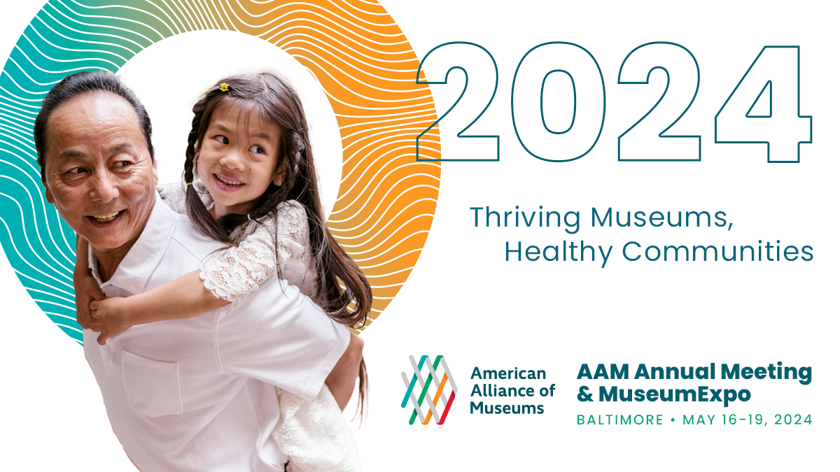

Simply copy and complete the template below
Date

Dear (supervisor’s name),

I am requesting your support for my attendance to the 2024 American Alliance of Museums Annual Meeting & MuseumExpo (AAM 2024), May 16-19 in Baltimore, MD. The conference will enable me to participate in (sessions/events/discussions) that are directly applicable to my position and will also allow me to network with others in the field to get new ideas and help strengthen our institution.

Why AAM 2024?
AAM 2024 is the only event of its kind that brings together the entire museum ecosystem to collaborate across disciplines to tackle the most pressing issues facing our field including topics around innovation in society, financial wellness, organizational culture, and museums in society.

How will this benefit (your organization)?
The leaders of relevant and resilient museums have long turned to the AAM Annual Meeting to gain deeper insights into emerging trends. At the AAM Annual Meeting, we will learn from and network with our peers who are addressing emerging issues, as well as the partners that can help us address the unique challenges and opportunities our museum and community faces.

At AAM 2024, I will be participating in hands-on sessions related to the following topics:

(Here you may want to list content that most apply to your responsibilities. Below is list of the AAM 2024 focus areas and the topics covered in each.)
Personal: intellectual curiosity and exploration; mental, emotional, and physical health and well-being; personal growth and development; work-life integration; and social connectivity, support, and belonging.
Organizational: accessibility in museums, strategies for employee agency and recognition, employee financial well-being, effective governance, fostering health and wellness initiatives, leadership and management, organizational culture, organizational financial health and sustainability, conducive physical and remote work environments, and optimizing workload and job design.
Community: civic engagement and participation, cultural and recreational opportunities, economic opportunities, education and lifelong learning, environmental sustainability, health services, infrastructure development, safety and security measures, building social connections and support networks, and fostering social equity, accessibility, and inclusion.
Society: the role of museums in building public trust, fostering accountability and transparency, contributing to peace and security, promoting social cohesion and inclusion, championing social justice and equity, and advancing technology access and connectivity.

I will gain insights into (job function, relevant topics, etc.) that I will be able to bring back and put to work at (name of your organization). AAM 2024 will give me strategies and actionable ideas that can address (challenges or opportunities your museum is facing).

The full price conference fee is ($xxx), but can be reduced by ($xxx) by registering early. I am seeking funding from (your organization) and I have listed all related expenses to the conference and detailed them below:

(Insert your travel cost numbers here.)

Roundtrip Airfare: ($xxxx)
Mileage (for locals traveling by car): ($xxxx)
Local Transportation: ($xxxx)
Hotel: ($xxxx)
Meals: ($xxxx)
Conference Registration: ($xxx)
Total costs associated with attending this conference are: ($xxxx).

When I return from AAM 2024, I will prepare a post-conference summary, including detailed recommendations that can further our (XYZ initiatives).

The knowledge I will gain from attending the AAM Annual Meeting will not only benefit (your profession), but (your organization) as well. I appreciate your consideration.

Sincerely,
(Your name here)

