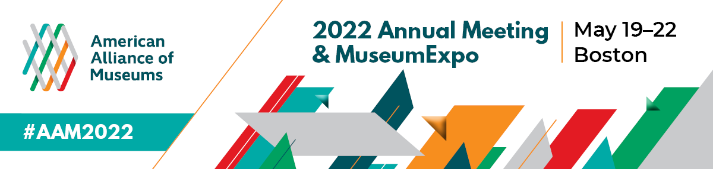

Simply copy and complete the template below
Date

Dear (supervisor’s name),

I request your permission to attend the 2022 American Alliance of Museums Annual Meeting & MuseumExpo (#AAM2022), May 19-22 in Boston, MA. The conference will enable me to participate in (sessions/events/discussions) that are directly applicable to my position and will also allow me to network with others in the field to get new ideas and help strengthen our institution.

Why #AAM2022?
#AAM2022 is the only event of its kind that brings together the entire museum ecosystem to collaborate across disciplines to tackle the most pressing issues facing our field including topics around innovation in society, financial wellness, organizational culture, and museums in society.

How will this benefit (your organization)?
The leaders of relevant and resilient museums have long turned to the AAM Annual Meeting to gain deeper insights into emerging trends. At the AAM Annual Meeting, we will learn from and network with our peers who are addressing emerging issues, as well as the partners that can help us address the unique challenges and opportunities our museum and community faces.

At #AAM2022, I will be participating in hands-on sessions related to the following topics:

(Here you may want to list content that most apply to your responsibilities. Below is list of the #AAM2022 focus areas and the topics covered in each.)
Organizational Culture: staffing and hiring, structuring for equity, empathetic culture, self-care and thriving at work, burnout prevention, effective leadership, decolonization, DEAI, and workforce trends.
Museums in Society: climate change, truth and democracy, advocacy, equity and social justice, DEAI, education, and community wellbeing.
Innovation: innovation in technology, digital engagement, exhibitions, audience research and evaluation, marketing and PR, collections stewardship, and curatorial practice.
Financial Wellness: revenue generation, new business models, development and fundraising, boards and governance, diversity and inclusion, and impact investing.

I will gain insights into (job function, relevant topics, etc.) that I will be able to bring back and put to work at (name of your organization). #AAM2022 will give me strategies and actionable ideas that can address (challenges or opportunities your museum is facing).

The full price conference fee is ($xxx), but can be reduced by ($xxx) by registering early. I am seeking funding from (your organization) and I have listed all related expenses to the conference and detailed them below:

(Insert your travel cost numbers here.)

Roundtrip Airfare: ($xxxx)
Mileage (for locals traveling by car): ($xxxx)
Local Transportation: ($xxxx)
Hotel: ($xxxx)
Meals: ($xxxx)
Conference Registration: ($xxx)
Total costs associated with attending this conference are: ($xxxx).

When I return from #AAM2022, I will prepare a post-conference summary, including detailed recommendations that can further our (XYZ initiatives).

The knowledge I will gain from attending the AAM Annual Meeting will not only benefit (your profession), but (your organization) as well. I appreciate your consideration.

Sincerely,
(Your name here)

